Evaluation of Treatment Efficacy Among Hard-Drug Using HIV Patients Receiving Highly Active Antiretroviral Treatment (HAART)
Marshall Roll
Introduction
This project attempts to understand how the two-year response to highly active antiretroviral treatment (HAART) for HIV differs for patients who use hard drugs like cocaine and heroin relative to non-hard drug users. Data was sourced from the Multicenter AIDS Cohort Study, which records treatment histories of HIV-infected men in four major American cities. The efficacy of the HAART treatment can be quantified through laboratory measures, such as viral load (number of HIV copies in 1 mL of blood) and CD4+ T cell count as well as participant-reported quality of life scores from the Short Form Health Survey (SF-36 physical and mental components, PCS and MCS). Thus, we sought to determine whether there is a significant association between hard drug use at baseline and the 2-year change in each of the four outcomes (viral load, CD4+ T cell count, SF-36 physical, SF-36 mental) when controlling for standard covariates (age, education status, smoking status, BMI, and race). Additionally, we tested to see if these associations are meaningfully changed when controlling for adherence to HAART.
Methods
Several variables were condensed for ease of interpretation and increased statistical power: education status was categorized as less than college degree or at least a college degree, smoking status as current smoker or non-current smoker, race as white non-Hispanic or other, and adherence as 95% 2-year treatment adherence and higher or less than 95% 2-year treatment adherence. The viral load outcome was transformed on the log10 scale for clinical interpretability. Negative covariate values or values of “999” were considered missing. Implausibly large BMI values (greater than 200) were relabeled as missing (ID = 179, BMI = 514). 13 individuals with missing BMI were thus dropped from the analysis. The mechanism of response missingness was assessed using exploratory descriptive statistics and was assumed to be missing at random (MAR).¹ Thus, a complete case analysis of participants with all outcomes non-missing at baseline and 2-year follow-up was conducted (n = 463). The primary analysis was conducted in both the frequentist and Bayesian frameworks for each of the four outcomes (2-year change in viral load, 2-year change in CD4+ T-cell count, 2-year change in PCS, and 2-year change in MCS). The primary predictor in these models was hard drug use and covariates included the baseline outcome value, baseline age, baseline education status, baseline smoking status, baseline BMI, and race. Secondary study sought to determine if adherence affects the relationship between hard drug use and the outcomes as either a mediator (hard drug use lowers adherence to HAART, which worsens clinical outcomes) or a confounder (adherence to HAART obscures the true relationship between hard drug use and clinical outcomes because it affects both separately). Descriptive analysis and Fisher’s exact test were conducted to determine the unadjusted association between hard drug use and adherence. To assess the relationship between adherence and the outcomes, identical models as in the primary analysis were fit, except including adherence as an additional predictor. Clinically meaningful differences across both analyses were: a 0.5 or more change in log10 viral load, a 50 or more change in CD4+ T cell counts, and a 2 or more change on the MCS and PCS. All frequentist analysis used the threshold of p-values below 0.05 to determine significance. For all Bayesian analyses, non-informative priors were used for regression coefficients (normal, mean 0, standard deviation 100) and for the variance term (half-normal, mean 0, standard deviation 100). In each model, 4 chains were used with 2500 total iterations of the Monte Carlo Markov Chain (MCMC) including 500 for warmup. Models were evaluated using WAIC, and MCMC convergence was assessed using Rhat, with values less than 1.01 indicating acceptable convergence. A difference in WAIC of 5 or more between two models was considered significant in the Bayesian framework. No correction for multiple comparisons was conducted as we have four distinct, pre-specified research questions. All analyses were conducted using R 4.5.1. Bayesian analysis was conducted using the brms package (version 2.23) with the cmdstanr backend (version 0.9.0).
Results
On average, hard drug users were more likely to be smokers and have education levels less than a college degree relative to non-hard drug users (Table 1). Hard drug users also had a lower mean baseline PCS and MCS compared to non-hard drug users. There are also many fewer hard drug users (n = 36) than non-hard drug users (n = 427). Across all regressions, results for equivalent Bayesian and frequentist regressions were similar (Table 2). On average, CD4+ T-cell count is predicted to decrease by 148.83 cells (95% CrI: (-209.59, -88.41)) more in hard drug users than non-hard drug users over a 2-year period while SF-36 PCS is predicted to decrease by an average of 3.33 points (95% CrI: (-6.09, -0.55)) relative to non-hard drug users over the same period; these effects are statistically significant. The average predicted 2-year decrease of 0.06 in log10 viral load (95% CrI: (-0.45, 0.33)) and of 0.28 points in SF-36 MCS (95% CrI: (-3.67, 3.17)) in hard drug-users relative to non-hard drug users are statistically insignificant. Standardized results are displayed in Figure 1.
Adherence to HAART is higher in hard-drug users (98%) than non-hard drug users (89%), though there are less hard-drug users overall (Table 1). A Fisher’s exact test between hard drug use and adherence shows no evidence of an association between the two (p = 0.11). Across all outcomes, differences in estimates of the effect of hard drug use are minimal between models that control for adherence (adjusted) and those that do not (unadjusted). Furthermore, the difference in WAIC between adjusted and unadjusted models does not exceed 5 for any of the outcomes; the largest difference is 4 for log10 viral load, with differences of 2 or less for all other outcomes (Table 2).
Discussion:
Hard drug use is significantly associated with both a reduction in 2-year CD4+ T-cell count and a decrease in 2-year SF-36 PCS relative to non-hard drug use; both differences are also clinically meaningful. This suggests that the beneficial effects of HAART therapy may be mitigated in hard drug users, and that further clinical interventions may be required in this sub-population. In secondary analysis, adherence was not found to be a mediator between hard drug use and clinical outcomes, as it is not significantly associated with either hard drug use or a change in outcomes. Further, the confounding effect of adherence is minimal, with only minor changes in the predicted estimates of hard drug use.
This study was conducted using a complete-case analysis, which is only theoretically valid if data are missing completely at random (MCAR). Data was assumed to be missing at random, which means that bias could be introduced if participants with more severe symptoms dropped out or of the study or died. In this case, there were few participants missing outcomes and no clear evidence showing that outcomes were worse among those who dropped out of the study, but nonetheless a complete-case approach may still lead to underestimated effect sizes by excluding the most symptomatic patients in the initial cohort. Additionally, this analysis may not be generalizable to HIV patients that are non-white, as race was collapsed due to lack of participants in other racial and ethnic categories.

Supplemental Endnotes
¹: Missingness was assessed by comparing the distribution of cases missing one outcome with the other three outcomes in a cohort of patients with at least one measurement at both baseline and two-year follow-up (n = 506). Of patients in this cohort missing viral load measurements (n = 19), the median CD4+ T-cell count is approximately 312, while the median count for patients with viral load measurements (n = 487) is approximately 517. Additionally, of patients missing SF-36 responses (n = 6), the median log10 viral count is 3.24 and CD4+ T-cell count is approximately 684, while those who are not missing responses (n = 500) have a median log10 viral count of 1.49 and a median CD4+ T-cell count of 512. All other combinations of missingness displayed similar medians across all outcomes. Due to the relatively small number of missing observations, lack of a clear pattern of worsening health outcomes with missingness, and investigator guidance, outcomes were assumed to be missing at random.
Acknowledgements
Data and guidance were provided by Dr. Camille Moore. Claude Sonnet 4.6 was used to debug code throughout this assignment, specifically for issues in constructing the tables and figures.
Reproducible Research
https://github.com/MarshallRoll/Advanced_Methods_Roll/tree/main/Project%201

Characteristic | Hard Drug Use N = 36 | No Hard Drug Use N = 427 | Overall N = 463
Age | 43.89 (9.52) | 43.10 (8.68) | 43.16 (8.74)
BMI | 23.62 (3.45) | 25.34 (4.39) | 25.21 (4.34)
Smoking Status
Non-smoker | 9 (25%) | 278 (65%) | 287 (62%)
Smoker | 27 (75%) | 149 (35%) | 176 (38%)
Race
White, Non-Hispanic | 19 (53%) | 277 (65%) | 296 (64%)
Other | 17 (47%) | 150 (35%) | 167 (36%)
Education
Less than College | 26 (72%) | 236 (55%) | 262 (57%)
College or More | 10 (28%) | 191 (45%) | 201 (43%)
log10 Viral Load | 4.58 (0.87) | 4.53 (0.93) | 4.53 (0.92)
CD4+ T-cell count | 360.04 (200.80) | 374.45 (202.29) | 373.33 (202.00)
SF-36 MCS | 42.01 (11.64) | 45.15 (13.77) | 44.91 (13.63)
SF-36 PCS | 49.16 (7.05) | 51.35 (9.00) | 51.18 (8.88)
2-year HAART Adherence
≥95% Adherence | 35 (97%) | 382 (89%) | 417 (90%)
<95 % Adherence | 1 (2.8%) | 45 (11%) | 46 (9.9%)
Table 1: All continuous variables reported as mean (SD) and categorical variables as n (%). All covariate values reported at baseline.

 |  | Frequentist |  | Bayesian
Outcome | Model | Hard Drug Use Effect (95% CI) | p-value | Hard Drug Use Effect (95% CrI) | WAIC
log10 Viral Load
 | Unadjusted | -0.059  (-0.456, 0.337) | 0.770 | -0.059  (-0.454, 0.332) | 1440.4
 | Adjusted | -0.013  (-0.409, 0.384) | 0.950 | -0.015  (-0.410, 0.381) | 1436.4
CD4+ T-cell Count
 | Unadjusted | -163.880  (-226.180, -101.580) | <0.001 | -148.832  (-209.589, -88.409) | 6124.6
 | Adjusted | -169.683  (-232.049, -107.317) | <0.001 | -153.718  (-213.912, -94.255) | 6122.6
SF-36 PCS
 | Unadjusted | -3.336  (-6.055, -0.617) | 0.017 | -3.326  (-6.094, -0.548) | 3223.8
 | Adjusted | -3.567  (-6.291, -0.843) | 0.011 | -3.590  (-6.273, -0.830) | 3222.3
SF-36 MCS
 | Unadjusted | -0.289  (-3.743, 3.165) | 0.870 | -0.277  (-3.665, 3.168) | 3444.0
 | Adjusted | -0.531  (-3.995, 2.933) | 0.764 | -0.519  (-4.018, 2.808) | 3443.8
Table 2: Effect of hard drug use represents the difference in predicted 2-year change in outcomes of an average hard drug user relative to an average non-hard drug user as predicted by both frequentist and Bayesian regression. Adjusted models include adherence as a covariate in addition to the standard covariates in the unadjusted model. Frequentist uncertainty is quantified by a 95% confidence interval, while Bayesian uncertainty is quantified by a 95% credible interval.

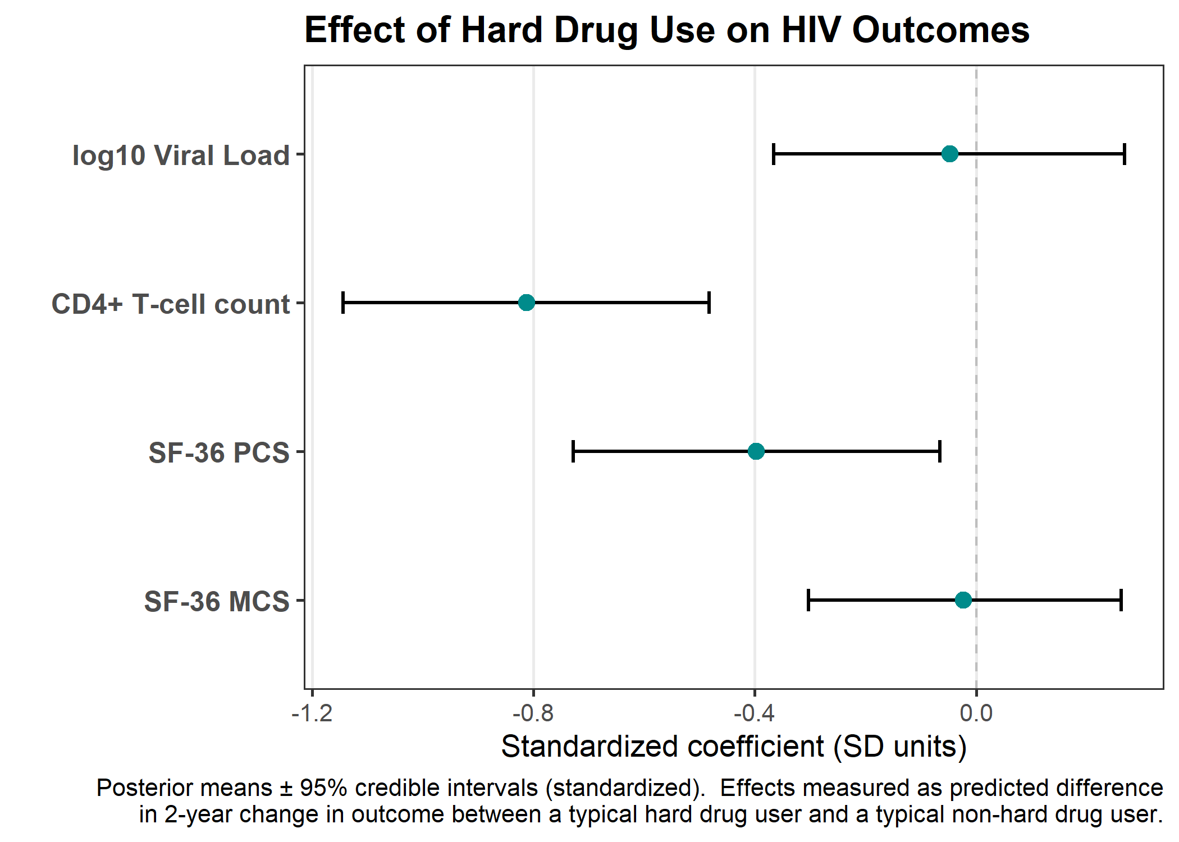
Figure 1: Point estimate of standardized posterior mean from unadjusted models with 95% credible intervals. All predictors normalized, with a one-unit decrease in standardized coefficient indicating that on average, hard drug users have an outcome value one standard deviation lower than non-hard drug users, after controlling for covariates. Effects measured as predicted difference in 2-year change in outcome between a typical hard drug user and a typical non-hard drug user.

